Sphere Radius

Definition
# Source: AI Source: Provided by: [Data Path: Persons Table -> ID Column: 1, Name_En Column: Motasem Essam] -> From: [ChatGPT] on [7/25/2026]
The radius of a sphere is the distance from the sphere’s center to any point on its surface. A radius can also refer to the line segment connecting the center to a point on the surface.
The radius is commonly represented by $R$ or $r$. It determines the sphere’s size and is used to calculate its diameter, surface area, and volume.
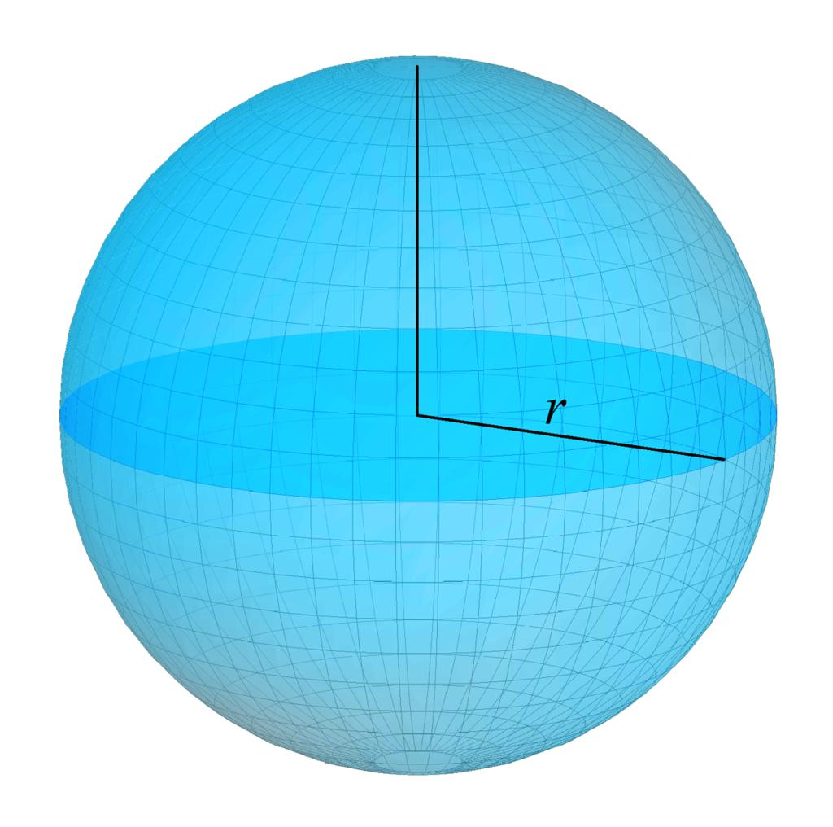
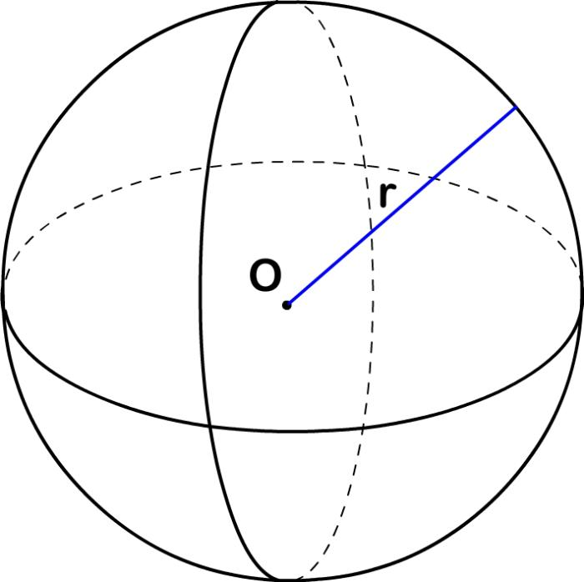
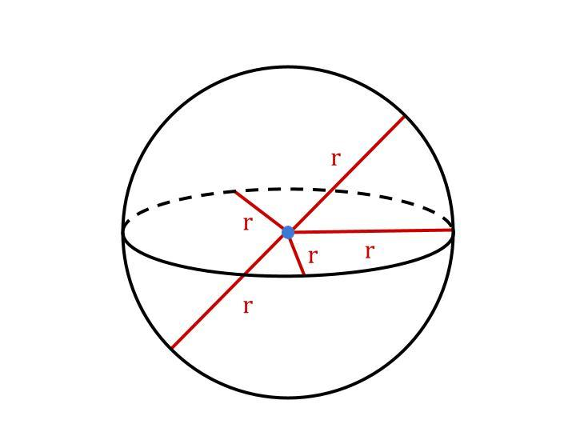

Simple Definition
# Source: AI Source: Provided by: [Data Path: Persons Table -> ID Column: 1, Name_En Column: Motasem Essam] -> From: [ChatGPT] on [7/25/2026]
The sphere radius is the distance from the center of a sphere to its outer surface.
- Every radius of the same sphere has the same length.
- A radius starts at the center and ends on the surface.
- The diameter is twice the radius.
- The radius is half the diameter.

Geometric Representation
# Source: AI Source: Provided by: [Data Path: Persons Table -> ID Column: 1, Name_En Column: Motasem Essam] -> From: [ChatGPT] on [7/25/2026]
Consider a sphere with center $O$ and a point $A$ on its surface.
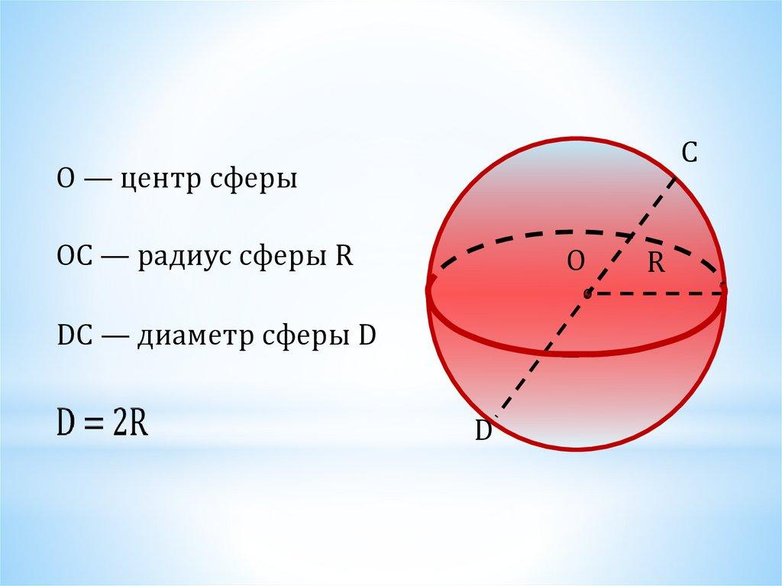
The radius is the segment $OA$, so:
$$OA=r$$
If $A$ and $B$ are opposite endpoints of a diameter passing through $O$, then:
$$AB=OA+OB=r+r=2r$$
Therefore:
$$\boxed{d=2r}$$
and
$$\boxed{r=\frac{d}{2}}$$
where $d$ is the diameter.

Types of Sphere Radius
# Source: AI Source: Provided by: [Data Path: Persons Table -> ID Column: 1, Name_En Column: Motasem Essam] -> From: [ChatGPT] on [7/25/2026]
The term sphere radius can be classified by how the radius is used or measured.
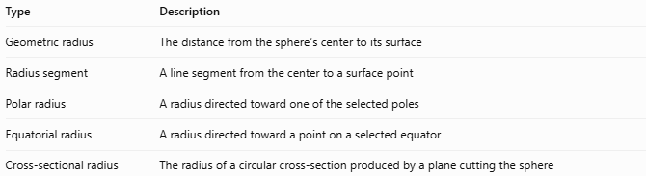
Type | Description
Geometric radius | The distance from the sphere’s center to its surface
Radius segment | A line segment from the center to a surface point
Polar radius | A radius directed toward one of the selected poles
Equatorial radius | A radius directed toward a point on a selected equator
Cross-sectional radius | The radius of a circular cross-section produced by a plane cutting the sphere
Important distinction: For a perfect mathematical sphere, the polar and equatorial radii are equal. They can differ for an oblate or prolate spheroid, which is not a true sphere.

Key Characteristics
# Source: AI Source: Provided by: [Data Path: Persons Table -> ID Column: 1, Name_En Column: Motasem Essam] -> From: [ChatGPT] on [7/25/2026]
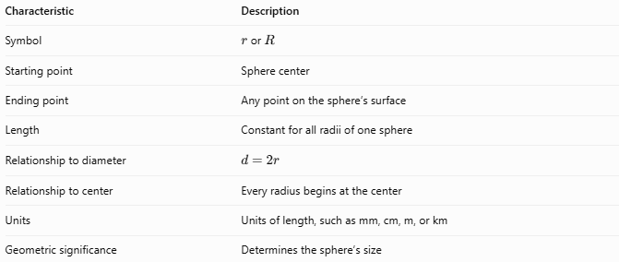
Characteristic | Description
Symbol | $r$ or $R$
Starting point | Sphere center
Ending point | Any point on the sphere’s surface
Length | Constant for all radii of one sphere
Relationship to diameter | $$d=2r$$
Relationship to center | Every radius begins at the center
Units | Units of length, such as mm, cm, m, or km
Geometric significance | Determines the sphere’s size

Mathematical Formulas

Radius from the diameter
# Source: AI Source: Provided by: [Data Path: Persons Table -> ID Column: 1, Name_En Column: Motasem Essam] -> From: [ChatGPT] on [7/25/2026]
$$\boxed{r=\frac{d}{2}}$$
Example: If the diameter is $18\text{ cm}$, the radius is $9\text{ cm}$.

Radius from the surface area
# Source: AI Source: Provided by: [Data Path: Persons Table -> ID Column: 1, Name_En Column: Motasem Essam] -> From: [ChatGPT] on [7/25/2026]
The surface area of a sphere is:
$$A=4πr^{2}$$
Rearranging gives:
$$\boxed{r=\sqrt{\frac{A}{4π}}}$$

Radius from the volume
# Source: AI Source: Provided by: [Data Path: Persons Table -> ID Column: 1, Name_En Column: Motasem Essam] -> From: [ChatGPT] on [7/25/2026]
The volume of a sphere is:
$$V=\frac{4}{3}πr^{3}$$
Rearranging gives:
$$\boxed{r=\sqrt[3]{\frac{3V}{4π}}}$$

Radius from the sphere equation
# Source: AI Source: Provided by: [Data Path: Persons Table -> ID Column: 1, Name_En Column: Motasem Essam] -> From: [ChatGPT] on [7/25/2026]
For a sphere with equation
$${\left(x-a\right)}^{2}+{\left(y-b\right)}^{2}+{\left(z-c\right)}^{2}=r^{2}$$
the radius is the positive square root of the constant on the right-hand side.
For example:
$${\left(x-2\right)}^{2}+{\left(y+1\right)}^{2}+{\left(z-3\right)}^{2}=49$$
Therefore:
$$\boxed{r=\sqrt{49}=7}$$

Relationship Between Radius and Cross-Section
# Source: AI Source: Provided by: [Data Path: Persons Table -> ID Column: 1, Name_En Column: Motasem Essam] -> From: [ChatGPT] on [7/25/2026]
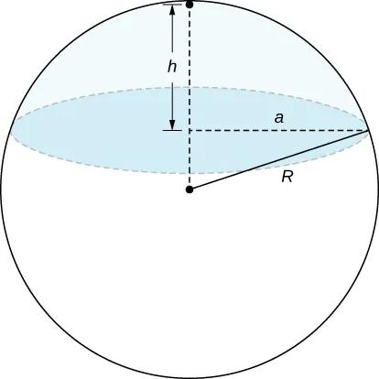
When a plane cuts a sphere, it generally creates a circular cross-section. The radius of that circle depends on the sphere’s radius and the plane’s distance from the center.
Let:
- $R$ = sphere radius.
- $a$ = cross-sectional radius.
- $x$ = perpendicular distance from the center to the cutting plane.
Using the Pythagorean theorem:
$$\boxed{a=\sqrt{R^{2}-x^{2}}}$$
Special cases:
- If $x=0$, the plane passes through the center and produces a great circle with radius $a=R$.
- If $0<\left|x\right|<R$, the plane produces a smaller circle with $a<R$.
- If $\left|x\right|=R$, the plane is tangent to the sphere and the intersection is a single point.
- If $\left|x\right|>R$, the plane does not intersect the sphere.

Worked Examples
# Source: AI Source: Provided by: [Data Path: Persons Table -> ID Column: 1, Name_En Column: Motasem Essam] -> From: [ChatGPT] on [7/25/2026]
Example 1 — Find the radius from the diameter
A sphere has a diameter of $24\text{ cm}$.
$$r=\frac{d}{2}=\frac{24}{2}$$
$$\boxed{r=12\text{ cm}}$$
Example 2 — Find the radius from the surface area
A sphere has a surface area of $100π{\text{ cm}}^{2}$.
$$\begin{aligned}4πr^{2}&=100π \\ r^{2}&=25 \\ r&=5\end{aligned}$$
$$\boxed{r=5\text{ cm}}$$
Example 3 — Find the radius from the volume
A sphere has a volume of $288π{\text{ cm}}^{3}$.
$$\begin{aligned}\frac{4}{3}πr^{3}&=288π \\ r^{3}&=216 \\ r&=6\end{aligned}$$
$$\boxed{r=6\text{ cm}}$$
Example 4 — Find the radius of a circular cross-section
A sphere has radius $R=10\text{ cm}$. A cutting plane lies $6\text{ cm}$ from the center.
$$\begin{aligned}a&=\sqrt{R^{2}-x^{2}} \\ &=\sqrt{{10}^{2}-6^{2}} \\ &=\sqrt{64}\end{aligned}$$
$$\boxed{a=8\text{ cm}}$$
The cross-sectional circle has a radius of $8\text{ cm}$.

Sphere Radius vs. Related Concepts
# Source: AI Source: Provided by: [Data Path: Persons Table -> ID Column: 1, Name_En Column: Motasem Essam] -> From: [ChatGPT] on [7/25/2026]
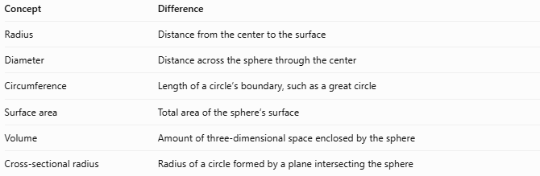
Concept | Difference
Radius | Distance from the center to the surface
Diameter | Distance across the sphere through the center
Circumference | Length of a circle’s boundary, such as a great circle
Surface area | Total area of the sphere’s surface
Volume | Amount of three-dimensional space enclosed by the sphere
Cross-sectional radius | Radius of a circle formed by a plane intersecting the sphere

Applications
# Source: AI Source: Provided by: [Data Path: Persons Table -> ID Column: 1, Name_En Column: Motasem Essam] -> From: [ChatGPT] on [7/25/2026]
- Engineering: Specifying spherical components, bearings, tanks, and rounded parts.
- Astronomy: Measuring the sizes of idealized spherical celestial bodies.
- Geometry: Calculating surface areas, volumes, and cross-sections.
- Manufacturing: Controlling the dimensions of spherical objects.
- Computer graphics: Defining the size of spheres in 3D scenes.
- Physics: Modeling spherical objects and calculating quantities that depend on their size.

Key Points
# Source: AI Source: Provided by: [Data Path: Persons Table -> ID Column: 1, Name_En Column: Motasem Essam] -> From: [ChatGPT] on [7/25/2026]
- The radius is the distance from the center to the sphere’s surface.
- Every radius of a given sphere has the same length.
- The diameter is twice the radius.
- The surface area is $4πr^{2}$.
- The volume is $\frac{4}{3}πr^{3}$.
- An offset plane creates a circular cross-section with radius $\sqrt{R^{2}-x^{2}}$, provided $\left|x\right|<R$.
- Radius is measured in units of length, while area and volume use squared and cubed units, respectively.

Conclusion
# Source: AI Source: Provided by: [Data Path: Persons Table -> ID Column: 1, Name_En Column: Motasem Essam] -> From: [ChatGPT] on [7/25/2026]
The sphere radius is one of the most fundamental measurements in solid geometry. It defines the sphere’s size and allows its diameter, surface area, volume, and circular cross-sections to be calculated. Understanding the radius also establishes the relationships between the sphere’s center, surface, poles, and great circles.

